Ayonna Jones

Dr. Jeffrey Yoshimi

COGS 202

15 April 2022

Cognitive Engineering Assignment Pt 2

As my technological product for evaluation, I have chosen the Central California Alliance for Health website. From now on I will refer to it as Central Alliance. I will be evaluating their online provider directory, used to explore and choose possible primary care physicians (PCP), specialists, and other providers. The directory also includes searches for hospitals, facilities, and medical equipment. For this assessment I will be looking only at the PCP option. I will be assessing the following features: search filters, provided information (office location and provider), page layout, and abbreviation usage.

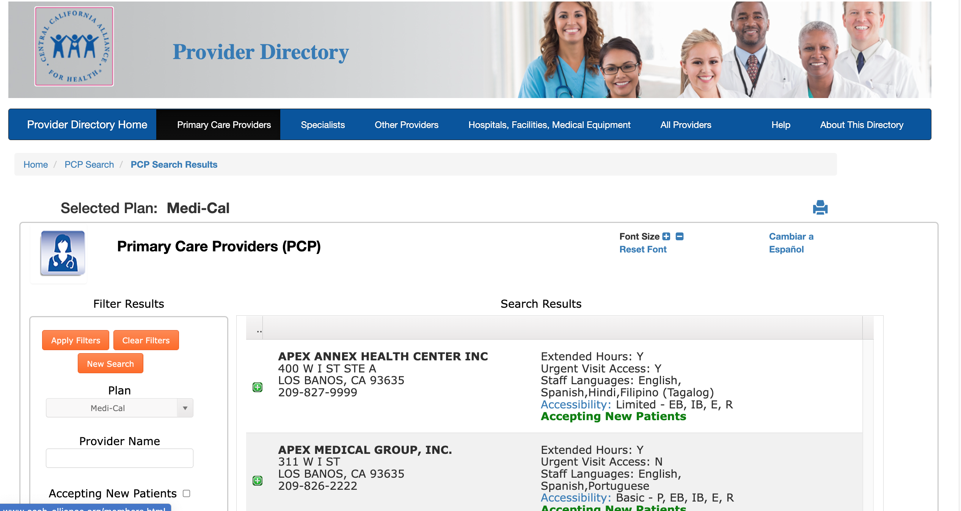

Figure 1. Central Alliance Provider Directory, Primary Care Providers

First, I will conduct an analysis of how these features support or don't support Nielsen's second principle of matching. It appears the service does seem to follow the second principle very well. It shows you the office location first, and once the green plus button next to the address is clicked on, it shows you all the available PCP’s. I may not know much about how this page format correlates to natural mapping, but it does seem to appear straightforward in nature. Easy for a person to use. Although this may not fall under the principle this website could do a better job of keeping their information up to date. The service also does a good job of avoiding any unnecessary internal jargon. However, I will say that a weakness it has in terms of the second principle is its use of abbreviations. Most of them make sense, like using “Y” for yes and “N” for no. However, some abbreviations can be a bit confusing and may lead people to develop questions that could be easily avoided (e.g., What does the “IB” stand for under accessibility?). I’m assuming those who have the medical conditions needed for accessibility could make sense of them, but I think it would be helpful to add a small key telling users what the abbreviations stand for.

Now, I will conduct an analysis of how these features support or don't support Nielsen's eighth principle of matching. I believe that the service reduced the signal-to-noise ratio as much as they could, providing all relevant information while also decreasing irrelevant information. However, once the green dropdown button is pushed and a PCP is selected for further details, there is a picture slot that is not filled for each PCP. Initially, I thought that there was supposed to be a picture of the provider instead of the purple silhouette. However, I noticed that is how it is for each provider. I understand that it is there to remind users that they are looking at a PCP, but I can imagine it not being very aesthetically pleasing to many users.

When analyzing the tradeoff between the two of these principles on this service website, I would say it is doing its best in both principles. Providing all relevant information while not overloading users with aesthetics. However, they could have made the layout a little more pleasing to the eye.

Expanding on some of the points mentioned previously, I would like to discuss two Laws of UX. First is Fitts Law, which states the following:

(1) Touch targets should be large enough for users to accurately select them

(2) Touch targets should have ample spacing between them

(3) Touch targets should be placed in areas of an interface that allow them to be easily acquired.

I mentioned briefly the green drop down arrows for office locations, revealing PCP options. The button is very small, which makes it difficult to select them. They could benefit from being a bit larger – at least the size of one’s cursor. I will say that each dropdown is given much distance from one another, which helps to reduce errors when choosing locations, and each one is easily accessible.

The second Law of UX I would like to address is Miller’s Law which states the following:

(1) Don’t use the “magical number seven” to justify unnecessary design limitations

(2) Organize content into smaller chunks to help users process, understand, and memorize easily.

(3) Remember that short-term memory capacity will vary per individual, based on their prior knowledge and situational context.

I noticed while exploring the online service that there are many providers and locations, which can make it hard to keep track and remember who a user would like as their PCP. I think that allowing users to “flag” or “like” providers while searching could make things a lot easier. It would help people with memory of PCP’s and provide a smaller, self-made list that one can look back at. These adjustments could make the service more digestible, and I believe users would thank the creators for it.